State machine diagram

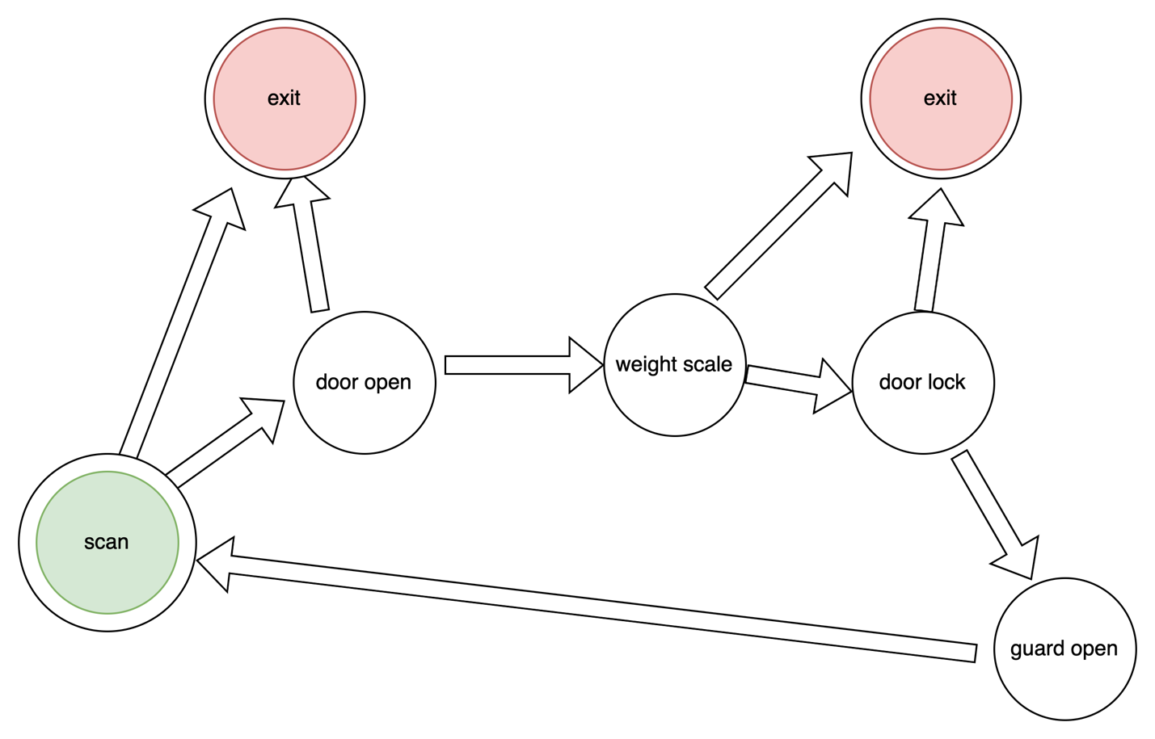

**State transitions**

Left scan or Right scan

Left open or Right open

Weight scale

Left close or Right close

Guard left unlock or Guard right unlock

Guard left lock o rGuard right lock

finish